Sportshall Athletics Rules & Adaptations

SPEED BOUNCE

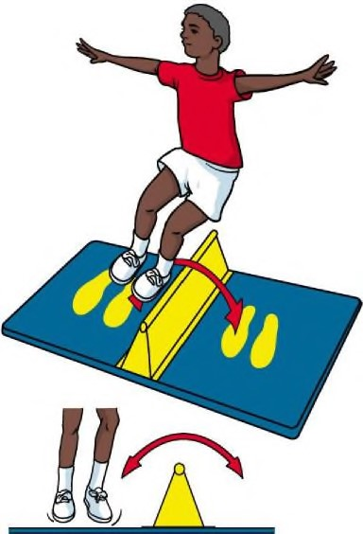 | Guidance Notes  - Please make the event as fun as possible for the pupils, teachers, support staff and yourself!  - Give loads of encouragement!  - Please demonstrate the activity and clearly explain what to do  - Use any non-fixed item approximately 30cm long and 15cm high to jump over, don’t worry if it’s lower or even use a line on the ground  - Record the number of bounces for each pupil on the scoresheet.

Rules
- Speed Bounce is a two-footed jump in which an athlete takes off and lands on both feet.
- The athlete should cross the middle object as many times as possible in thirty seconds. If the athlete clips or brushes the middle object then the jumps are still counted.
- Each athlete gets three attempts with the best score recorded on the score sheet – alternate attempts between pupils to give everyone a well deserved rest.

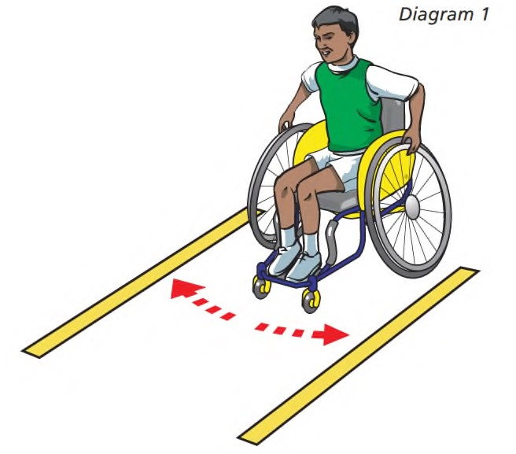
Adaptations
- Pupils with restricted mobility can use a lower wedge or remove the wedge altogether.
- Manual wheelchair and powerchair users should attempt how many times in 30 seconds they can alternately touch lines of flat objects placed 10cm either side (or in front and behind) of the front wheels. Each touch counts as one.
- Visually impaired pupils may benefit from a black and white striped wedge tip or line.
- Any pupils who are unsteady on their feet can hold onto a support aid or person if it makes them feel safer

Sportshall Athletics Rules & Adaptations

HI-STEPPER
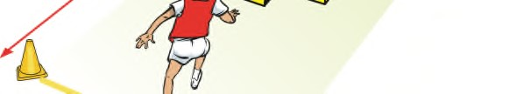 | Guidance Notes  - Please make the event as fun as possible for the pupils, teachers, support staff and yourself!  - Give loads of encouragement!  - Please demonstrate the activity and clearly explain what to do  - One ‘judge’ may be used to time this event.  - Use any non-fixed item approximately 30cm long and 10cm high to jump over, don’t worry if it’s lower or even use a line on the ground  - An adequate run off area should be provided at each end of the course.  - Record each pupil’s best time on the scoresheet in seconds eg. 75 seconds

Rules
- The athlete begins from a standing position behind the start line.
- On the ‘Go’ command the athlete runs over the hi-stepper placing one foot in each of the squares.
- The athlete must place one foot over the return line before turning and repeating the hi-stepper in the opposite direction.
- After completing the hi-stepper twice (there and back only) the clock is stopped when they re-cross the start line.
- Each athlete gets three attempts with their best time recorded on the score sheet – alternate attempts between pupils to give everyone a well deserved rest.
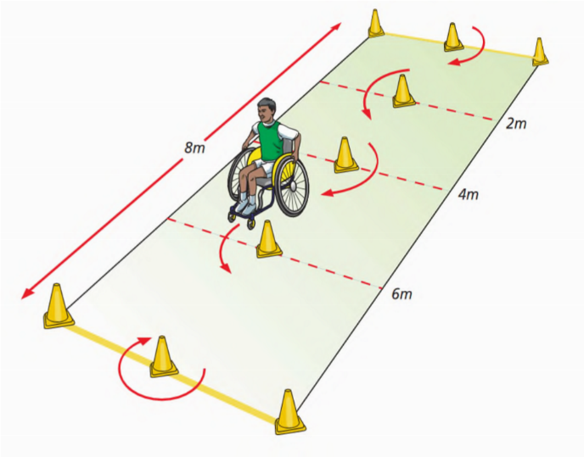

Adaptations
- Wheelchair users should aim to complete an 8 metre distance in a slalom course with cones placed at 2, 4 and 6 metres (there and back).
- Wedges can be removed for athletes using a kaye walker or athletes who are visually impaired if necessary
- This course can be set up for any pupils who find the hi-stepper course too challenging

Sportshall Athletics Rules & Adaptations
TARGET THROW
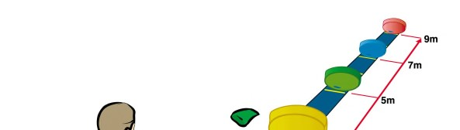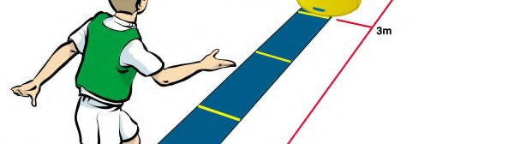 | Guidance Notes  - Please make the event as fun as possible for the pupils, teachers, support staff and yourself!  - Give loads of encouragement!  - Please demonstrate the activity and clearly explain what to do  - Two ‘judges’ are recommended, one to help the thrower to the correct target and one to record the score.  - Record each pupil’s best points score on the scoresheet

Rules
- The targets are to be placed at a distance of 2m, 4m, 6m and 8m from the throwing line (different to illustration).
- The athlete stands behind the throwing line and throws four coloured bean bags into the same coloured target, only one bean bag into each target. Use large hoops as targets.
- 5 points for 1st hoop, 10 points for 2nd hoop, 15 points for 3rd hoop and 20 points for 4th hoop.
- Maximum score = 50 points
- Each athlete gets three attempts with the best score recorded on the score sheet – alternate attempts between pupils to give everyone a well deserved rest.

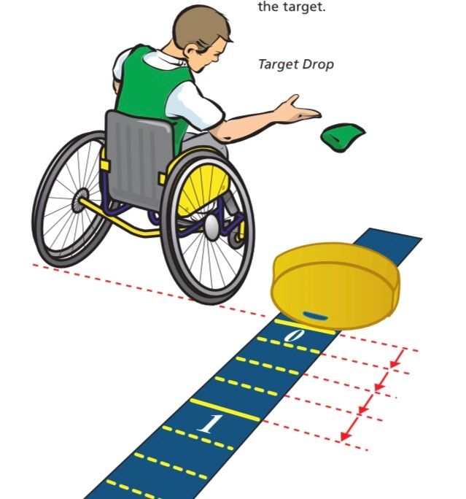
Adaptations
- For athletes with a visual impairment, you can clap and talk loudly over the target area.
- If mobility is not good then athletes can travel up to the side and drop the beanbags into the target
- Please adapt the distance of the targets to suit the needs and ability of your pupils.

Sportshall Athletics Rules & Adaptations

STANDING LONG JUMP
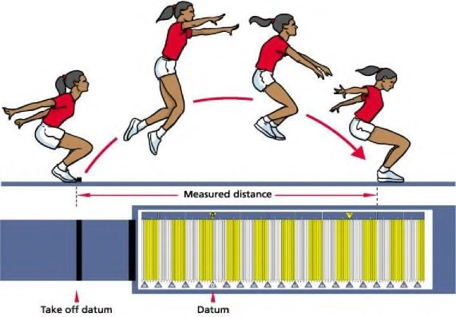 | Guidance Notes  - Please make the event as fun as possible for the athletes, teachers and yourself!  - Give loads of encouragement!  - Please demonstrate the activity and clearly explain what to do  - It is recommended that two ‘judges’ are used, one to help the take off and one to mark the landing.  - Following each jump, measure from the jump line to the back of the heel  - Record the pupil’s best jump on the scoresheet in metres and centimetres eg. 0.80m or 1.35m

Rules
- The athlete must stand with both feet behind the take-off line.
- The athlete should jump as far as possible from a standing position, with a two footed take off, where possible.
- The athlete is not required to hold the landing position and may step forward after the jump.
- Each athlete gets three attempts with the best score recorded on the score sheet – alternate attempts between pupils to give everyone a well deserved rest.

Adaptations
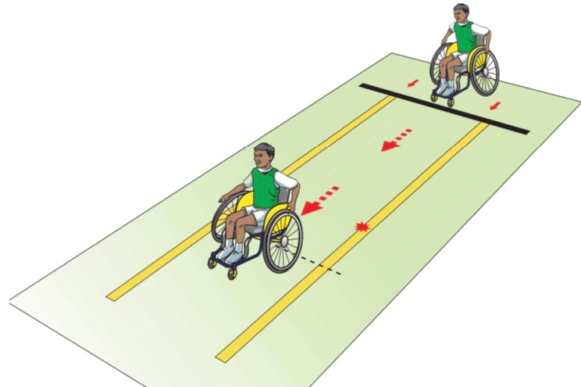
- Any pupils who are unsteady on their feet can hold onto a support aid or person if it makes them feel safer
- Manual Wheelchair users are to use a single push of their wheels and see how far they achieve whilst travelling in a straight line. The distance recorded is from zero to where they went off course.
- Powerchair users are to use a single push and hold of their controls and see how far they achieve whilst travelling in a straight line. The distance recorded is from zero to where they went off course.

Sportshall Athletics Rules & Adaptations

JAVELIN TARGET THROW

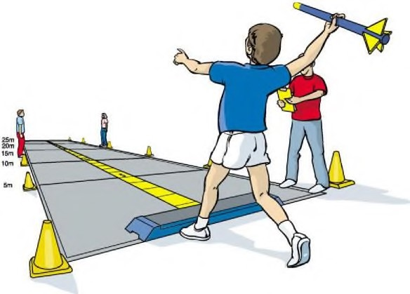 | Guidance Notes  - Please make the event as fun as possible for the athletes, teachers and yourself!  - Give loads of encouragement!  - Please demonstrate the activity and clearly explain what to do  - It is recommended that two ‘judges’ are used. One judge to assist the throw and one to record the landing.  - Do not have more Javelins out than needed  - Record the pupil’s best distance on the scoresheet to the nearest 25cm  eg. 4.75m

Rules
- The javelin is thrown from a standing position with both feet behind the throwing line and in contact with the floor. Stand with opposite leg from throwing arm at start line.
- DO NOT allow the javelins to be thrown back to waiting athletes.
- Each athlete gets three attempts with the best distance recorded on the score sheet – alternate attempts between pupils to give everyone a well deserved rest.

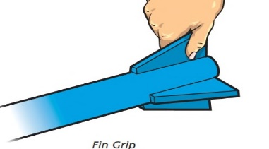
Adaptations
- For athletes with a visual impairment, you can clap and talk over the target area.
- Athletes with restricted mobility can use a mini Javelin
- An alternative grip (by the fin) can be encouraged.
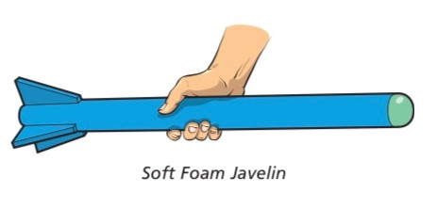
- If your school does not have foam javelins, please adapt by using any other appropriate, safe equipment that can be used for over-arm throwing eg. bean bag or ball.

Sportshall Athletics Rules & Adaptations

SEATED CHEST PUSH
Guidance Notes
- Please make the event as fun as possible for the athletes, teachers and yourself!
- Give loads of encouragement!
- Please demonstrate the activity and clearly explain what to do
- It is recommended that two ‘judges’ are used, one to help the throw and one to record the landing and stop the ball.
- Record the pupil’s best distance on the scoresheet to the nearest 10cm
eg. 0.90m or 1.60m
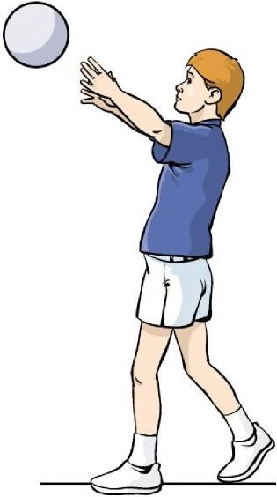

Rules
- The athlete sits down and holds the ball (football or volleyball) against their chest and pushes with both hands.
- The athlete’s chest should face forward to aid the throw
- The distance thrown is measured from the throwing line to the point where the ball first lands.

Adaptations
- Different weighted balls can be used for those with low mobility eg. foam ball, bell ball, tennis ball
- A one-handed push/roll is permitted where appropriate
- For athletes with a visual impairment, you can clap and talk at the target direction.

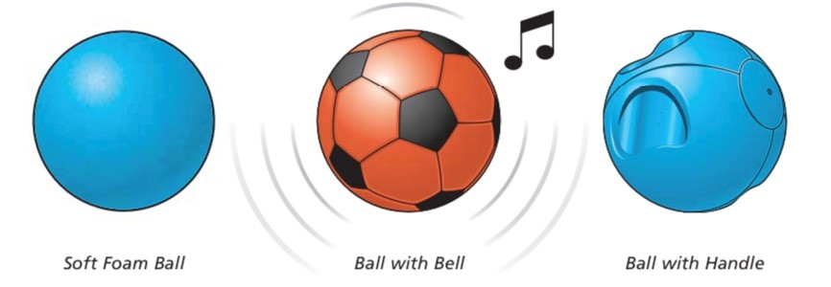

Sportshall Athletics Rules & Adaptations
Guidance Notes
- Please make the event as fun as possible for the athletes, teachers, support staff and yourself!
- Give loads of encouragement!
- Use the length of a badminton sized court – 12 meters
- Running – Each pupil completes one length, there and back
- Slalom Race - Each pupil completes one length, there and back.

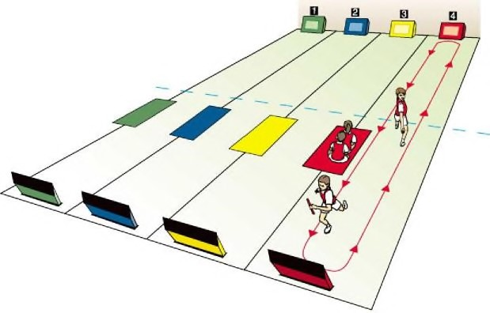
RUNNING RACES

Rules
Running Race
- Up to four pupils can race at the same time – 2 metres apart across the start line
- On the Go command, athletes will run to the end of the badminton court or 12 metre marking then turn to run back to the start line.
- Each athlete gets three attempts with the best time recorded on the score sheet – alternate attempts between pupils to give everyone a well deserved rest.
- Try to put pupils of similar ability into the same race where possible
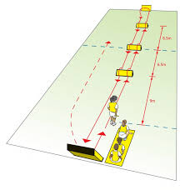
Slalom Race
- Set up a fun slalom / obstacle race using cones set out and 2 metre intervals.
- Up to four pupils can race at the same time – 2 metres apart across the start line
- On the Go command, pupils should complete a full circle of each cone before continuing to the next one and repeating the process on so on until the end of the 12 metres, on the way back pupils should slalom through the cones to the finish line.
- Each athlete gets three attempts with the best time recorded on the score sheet – alternate attempts between pupils to give everyone a well deserved rest.
- Try to put pupils of similar ability into the same race where possible
If your COVID risk assessment allows, why not make this a relay race to encourage teamwork and even more fun!!

